Volume
1

Bike Tracker
Your Bike Security Solution

User Manual

Table of Contents

Section 1: Device Installation………………………1

Section 2: Application Installation…………………2

Section 3: Wifi Setup ……………………………….4

Section 4: Bike Tracker in Action………………….5

Section
1

Device Installation
Connecting the Bike Tracker to your bike
T
he Bike Tracker device will be installed underneath the user’s bike seat on the bike post. While the device will be in plain sight, the reflective casing will disguise it from thieves by looking like a regular bike reflector.

Remove the screw closest to the circular clamp.

Place the clamp around the bike post. Place the clamp as close to the top of the bike as possible. Make sure that the hole for charging is at the bottom

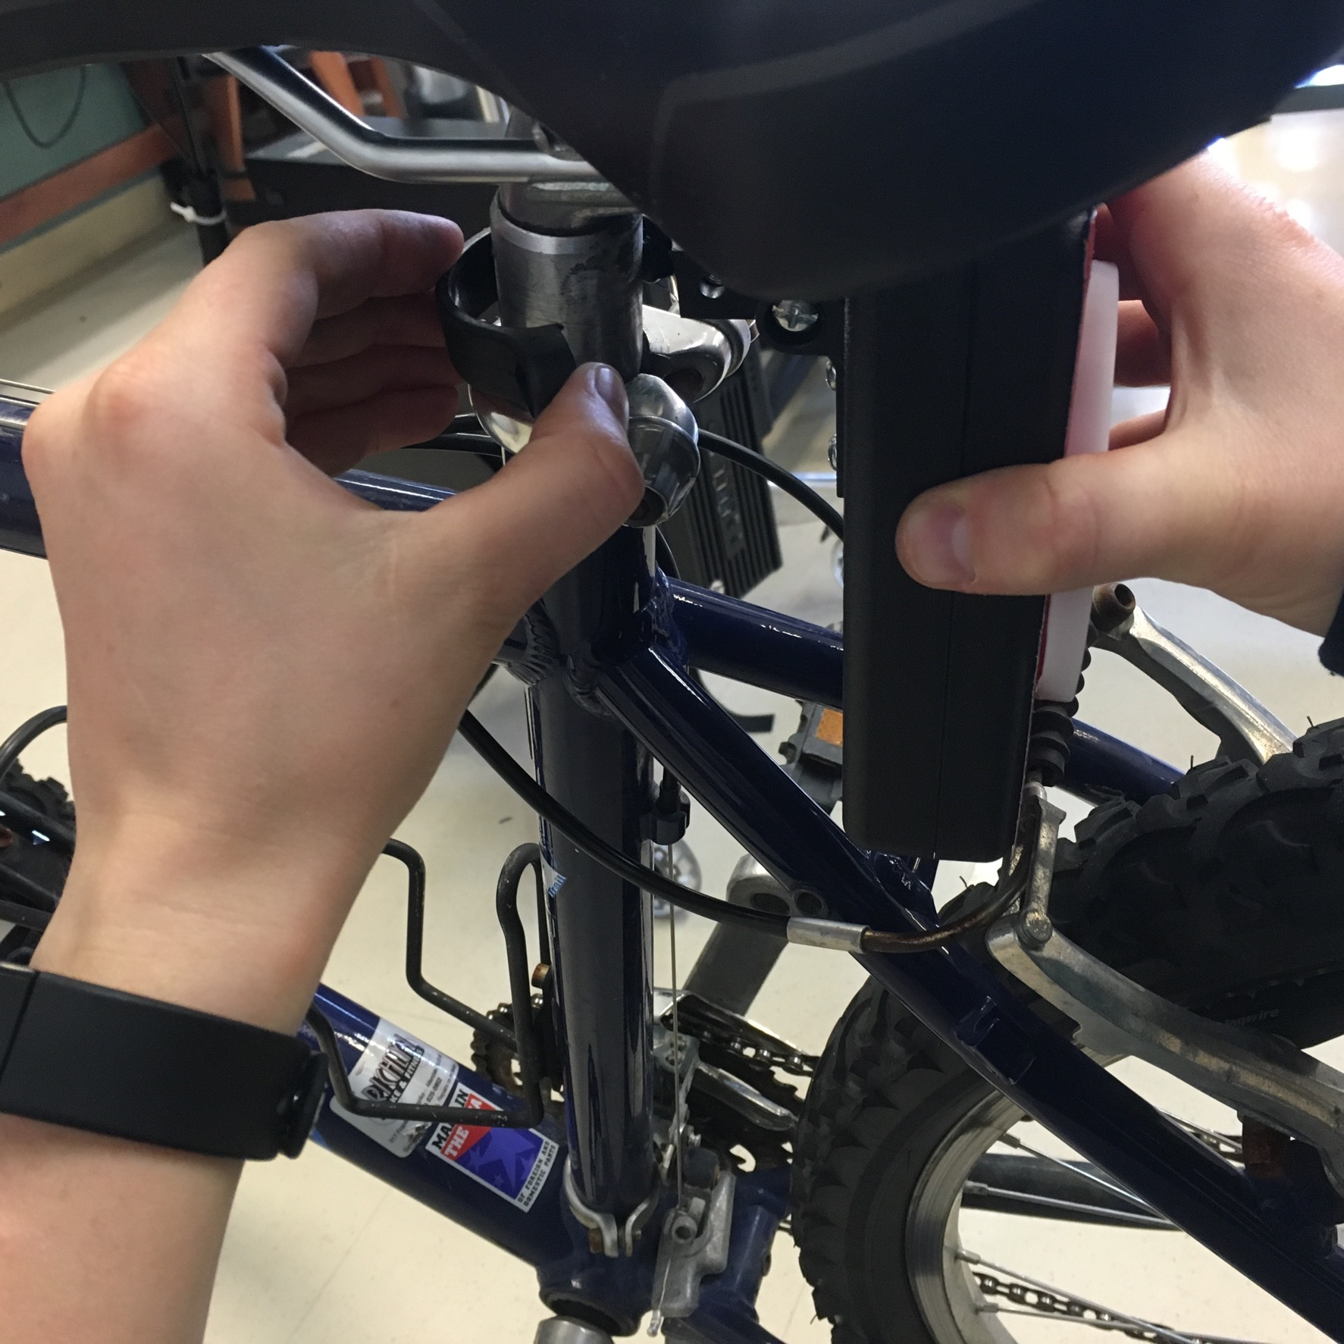

Screw the clamp until tight.
Section
2
Bike Tracker App Installation
Installing the Bike Tracker App to your cellular device
I
n order to use the BikeTracker, a user must have access to the both an iPhone and a Mac computer. The user will also have to download a program to connect the app to his/her phone, if he/she doesn’t have the program already.

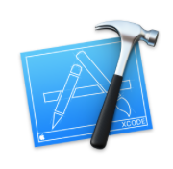
Download XCode from App Store on Mac

Download BikeTracker App File - Go to http://seniordesign.ee.nd.edu/2016/Design%20Teams/biketra/documents.html and download the file entitled “BikeTrackerApp”

Extract the Zip File and open the file entitled “Bike Tracker. xcodeproj

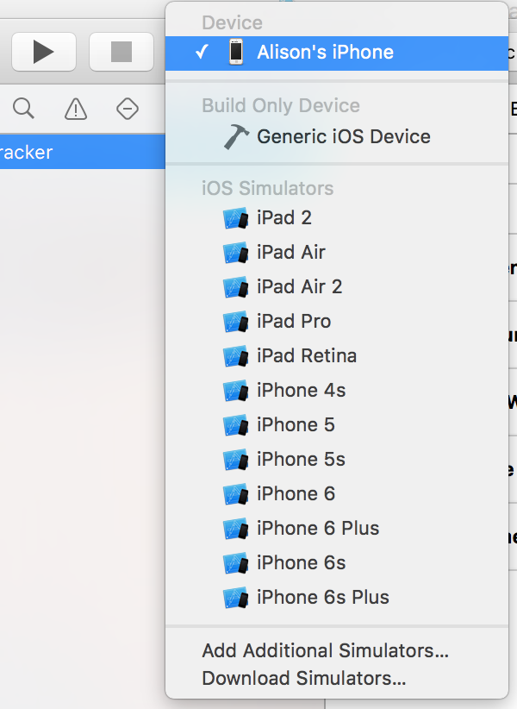
In the upper left hand corner you will see the following buttons. Click on the device menu and select the name of your iPhone

Press the Run button (the top left button)

Follow the pop-up instructions to verify you app development certificate.

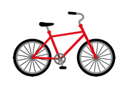
A new application will appear on your iPhone with the logo on the left

Section
3
Wifi Setup
Connecting the Bike Tracker to wifi
t
he Bike Tracker uses access points to establish a wireless connection. The wifi connection needs to be established the first time the Bike Tracker is turned on, and it will then continue to connect to the selected wifi until that connection has been dropped.

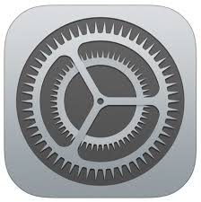
On iPhone, select Settings -> Wifi

Turn on Wifi and select “BikeTracker”

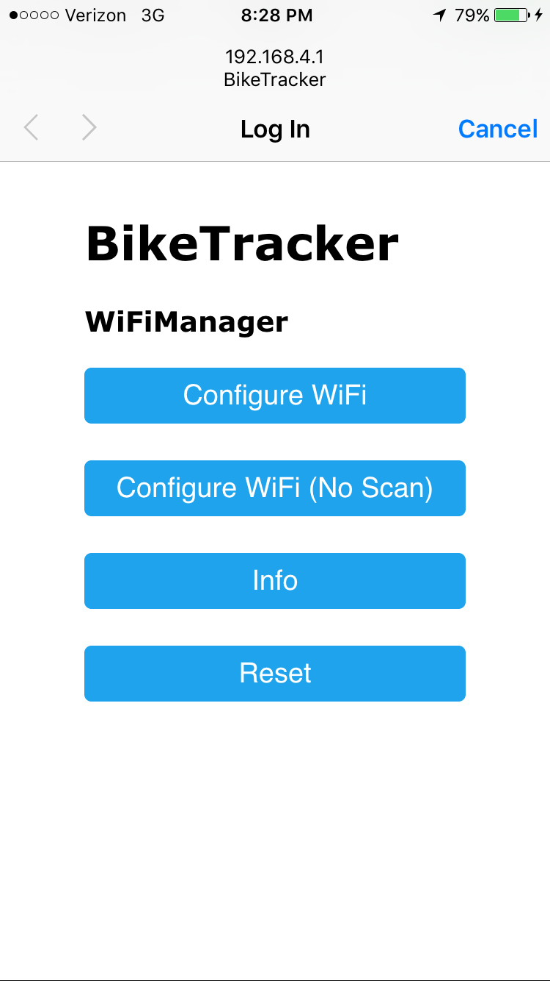
A new window will appear on your phone (see below). Select “Configure Wifi”. A list of available wireless connections will now appear.

A Wifi Manager will now
appear with available wifi
networks and their
respective signal strengths.
Select the wifi you would
like to connect to use.
Type in password (if
necessary) and select save.
Section
4
Bike Tracker in Action
Using the Bike Tracker to keep your bike safe!
t
he Bike Tracker App has a simple interface that interacts with the tracker device. The app tells the device to run in either Park Mode or Riding Mode, and will also alert the user if motion has been detected by the tracker.
Tracker On/Off –
The Tracker On/Off toggle will place the BikeTracker in Park Mode (Tracker On) or Riding Mode (Tracker Off). The toggle is initially set to Tracker Off and will only begin to track when the app is opened and Tracker On is selected.
When in Park Mode, the tracker will update periodically update the location of the bike, which will subsequently be displayed on the Track Map. A notification will appear on the Track Map if the tracker is on, but there is no GPS fix.
When in Riding Mode, the tracker will not update look for GPS locations or alert user when bike is in motion.

Last Location On/Off –
When Last Location On is selected, the last known location of the bike will display on the Track Map. If the tracker is on and receiving GPS locations, the map will display both the current and most recent bike locations. If both points are not visible, they are likely overlapped. The color should then toggle between purple and green, thus showing the last two reads have been in the same location.
Motion Detected -
When the bike is in Park Mode, the user may be alerted that their bike is moving and a new “Found Bike” button will appear on the map. This alert is created due to activity detected by an accelerometer on the tracker device. The tracker device will then repeatedly update its location and display this location on the app interface. When the user has found its bike, he/she should select the “Found Bike” button. This will alert the tracker device that it should return to its periodic tracking mode.
MQTT Server Connection -
If connection between the MQTT Server and the phone application is lost, the user will be alerted accordingly. The server will attempt to reconnect by itself. If issues continue, try to connect your phone to a different Wifi network or restart the application.

Charging -
Occasionally the Bike Tracker will need to be charged. This will be noticed when GPS location cannot be found for an extended period of time or the user opens the tracker and no lights are on. To charge the device, place your bike in a secure location and remove the tracker from the bike. Charge the tracker using the provided cord.

Reset -
If the Bike Tracker does not appear to be functioning properly, press the reset button using the User Application.

